Health benefits of eating sustainably

• There are 1 billion overweight and 300 million obese adults worldwide
• 300,000 deaths per year in the US can be attributed to obesity1
• Obese individuals are at a 50-100% higher risk of premature death1

US Obesity Trends by State
Obesity is defined as a body mass index (BMI) index of 30 or greater. BMI is calculated from a person’s weight and height. The maps show the percent of US adults who are obese.

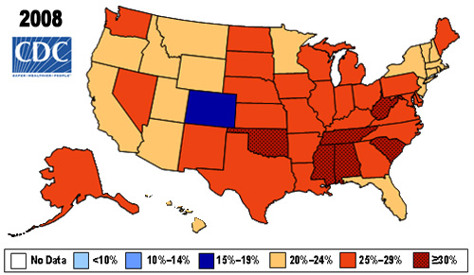 cdc.gov

Why? Influences from the Toxic Environment

According to Wang and Brownell at Yale, “animals are adept at regulating a very steady body weight until they are placed in a situation in which palatable, high-fat, high-sugar food is consistently accessible to them. Under these conditions, laboratory animals overeat and become far heavier than their normal body weight, even when nutritionally balanced food is available.” They further assert, “although individuals have the ability to make choices, it is difficult to make healthy choices and to succeed when the environment is stacked against them.”

Calorie-dense but nutrient-poor food
The past 60 years saw an increase in the consumption of energy-dense foods, high in saturated fats and sugar. Energy-dense, nutrient-sparse alternatives replaced low calorie, nutrient-rich foods and drinks; for example, soda replaced milk and salty snacks replaced fruits. One can of A&W Root Beer has 4 tablespoons of sugar and 170 calories. The same amount of skim milk has 120 calories and nutrients like protein, calcium, and vitamin D. We now eat on the run and rely on a “quick fix” to satiate hunger. Fast food is often highly processed and fried in oil with saturated fats. Eating out increased 89% from 1972 to 1995. Research shows that people consume almost 200 more calories per day eating outside the home.2

Exercise
Also, as Americans consume more energy, they expend fewer calories. One-fourth of Americans report being completely sedentary. Half of children walked to school in 1950, but only 10% of children report walking to school today.2 Furthermore, most popular leisure activities, such as watching television, require little to no physical activity.

Portion size
Portion sizes of some foods have increased two-fold since the 1950s -- bagels are twice the size and
candy bars come in “King Size.” A turkey sandwich may be a healthy choice for lunch, but may
contain enough meat and bread for two meals. Some super-sized fast food meals pack the daily calorie recommendations into a single meal.

Portion size: 1987 versus 2007

Cheeseburgers Soda
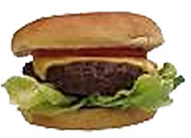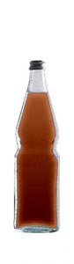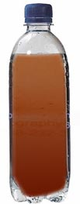
1987: 333 calories 2007: 590 calories 1987: 85 calories 2007: 250 calories

Spaghetti and meatballs

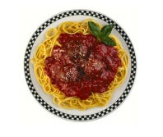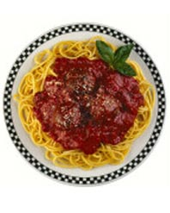
1987: 500 calories 2007: 1025 calories

Human health consequences of obesity

• Coronary heart disease
• Type 2 diabetes
• Cancers (endometrial, breast, and colon)
• Hypertension (high blood pressure)
• Dyslipidemia (for example, high total cholesterol or high levels of triglycerides)
• Stroke
• Liver & gallbladder disease
• Sleep apnea and respiratory problems
• Osteoarthritis (a degeneration of cartilage and its underlying bone within a joint)
• Gynecological problems (abnormal menses, infertility)

General guidelines
Eat more…
- Fruits and vegetables
• Fill half your plate
• The more color variety, the more nutritious
- “Whole Grain” carbohydrates (oatmeal, whole wheat bread, brown rice)4
• Whole grains contain fiber which slows digestion and helps you feel full longer
• Wheat bread is often highly processed. Don’t be fooled by the “wheat” title—look for “whole”!
• Items labeled “multigrain” are not necessarily whole grain; check the label.
- Protein from chicken, fish, grass-fed meats, and vegetable sources, such as beans and nuts
- Unsaturated fats9
• Substitute omega 6 or omega 3 unsaturated fatty acids for dairy and animal fat
• Fish, beans, almonds, olives, avocados and many seeds contain the essential fatty acids that are beneficial to heart and skin health
• Olive oil and canola oil are good sources of unsaturated fats

Eat less…
- Trans and saturated fats
• Choose lower fat dairy options and lean protein such as fish or skinless poultry
• Substitute grass-fed meats for grain-fed
• Stay away from fried food and large amounts of butter or baked goods
- Soda and fruit juices
- Red meat 9
- Food in general; be aware of portion sizes for your weight and activity levels:
• One serving of meat looks like a deck of cards: most Americans consume twice the daily recommended value for protein. Other sources of protein such as beans, nuts, and tofu will help round out strengthen your diet.
• One serving of peanut butter or salad dressing is about the size of a golf ball
• When eating out, take half your meal to go and stretch your dollars, not your waistline.

Try to …
- Get 30 minutes of physical activity daily
- Take the stairs instead of the elevator; ride your bike to class or work. (This also benefits the environment!)
- Support parks, bike trails, and safe recreational spaces for all Atlanta residents. It is easy to forget that outdoor recreation is dangerous in some parts of town, which limits exercise.
- Promote efforts to make fresh foods available in all neighborhoods and schools.

Don’t forget…
Every person’s diet needs are different, but most researchers agree about certain basic principles of healthful diets: variety in food intake, moderation in calories, largely plant-based, and minimally processed.

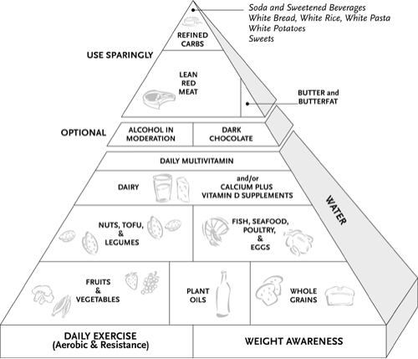
<http://www.eatdrinkandweighless.com/images/img-pyramid-lg.gi>

Becca Gittelson and Brooke Mills for the Sustainable Food Committee at Emory University

“WHO | Obesity and overweight." October 2009. <http://www.who.int/dietphysicalactivity/publications/facts/obesity/en/>.
Wang, S.S., & Brownell, K.D. 2005. “Public policy and obesity: The need to marry science with advocacy.” Psychiatric Clinics of North America, 28:235-252.
United States Department of Agriculture. October 2009. <http://www.mypyramid.gov/>.
"Why People Become Overweight - Harvard Health Publications." November 2009. Health Information and Medical Information - Harvard Health Publications. <http://www.health.harvard.edu/newsweek/Why-people-become-overweight.htm>.
National Resource Center on Nutrition, Physical Activity & Aging. April 2010. <nutritionandaging.fiu.edu/DRI_and_DGs/mypyramid-portions.ppt>
"The Surgeon General's Call to Action to Prevent and Decrease Overweight and Obesity." October 2009 Office of the Surgeon General. <http://www.surgeongeneral.gov/topics/obesity/calltoaction/fact_consequences.htm>
Willett, W. 2001. Eat, Drink, and Be Healthy: The Harvard Medical School Guide to Healthy Eating. New York: Free Press..
Nestle, Marion. March 2010. “Confused about nutrition? Eat Food!” Food Politics. <http://www.foodpolitics.com/2010/02/confused-about-nutrition-eat-food/>

